Public Notice
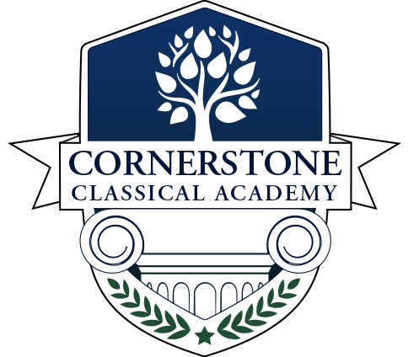
Audit & Financial Oversight Committee
Cornerstone Classical Academy

Agenda

Call to Order & Roll Call

Reading of the Mission Statement

Agenda Approval

Public Comments

Reports

Unfinished Business

New Business

Adjourn

Meeting Details

When: July 31, 2023, 12PM

Where: HYBRID (Physical + Virtual) Physical:
2360 St Johns Bluff Road, Jacksonville, FL 32246
Virtual Location:
Click here to join the meeting
Meeting ID: 227 349 080 372
Passcode: QuLB9F

Who: This meeting is open to the public and will include discussion regarding matters pertaining to Cornerstone Classical Academy.

Public Comments: All public comment requests must be emailed to the board Treasurer, Mrs. Sally Lutz, with your name and address within 24 hours or more of the meeting to salutz@cornerstoneclassical.org

